
eModern Decor, Inc.
11223 Rush St. Unit H
South El Monte, CA 91733
Tel: (626) 774-2294
Fax: (626) 450-0561

Custom Made Cabinet Form
Customer Info:
Name: ______________________
Phone (Home): ______________ Phone (Mobile): ______________
Address: ______________
City: ______________ State: _________ Zip: _______
Email: _____________________

Desired Kitchen Type:

Straight Kitchen  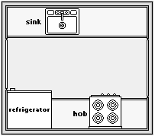 | U-Shaped Kitchen  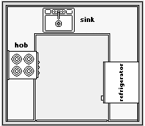 | L-Shaped Kitchen  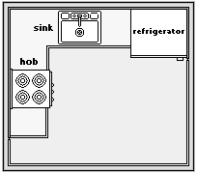

Other: _________________

Cabinet Finish:
Laminate Finish:
We use Formica Laminate and you may choose from below:
http://www.formica.com.hk/category.php?id=1

Wood Grains Finish Color Code: _______
Please refer to: http://www.formica.com.hk/product.php?id=1&sid=9

Metal Finish Color Code: _______
Please refer to: http://www.formica.com.hk/product.php?id=1&sid=8

Solid Color Finish Color Code: _______
Please refer to: http://www.formica.com.hk/product.php?id=1&sid=2

PU Glossy Paint Finish Color: _______
Tempered Glass Finish Color: _______
Other: ______________

Note: If you cannot decide what finish/color or style at this moment, you may choose at a later time and we will help you to decide. Our estimate is based upon sizes and finish type.

Cabinet Pricings:
Finishes | Price / Sq ft | Height (standard) | Depth (standard)
Wood Grains | $165 (Base Cabinet) | 36” | 24”
Wood Grains | $160 (Top Cabinet) | 32” | 12”
Wood Grains | $330 (Pantry Cabinet) | 96” (max) | 24”
Solid Color Finish | $165 (Base Cabinet) | 36” | 24”
Solid Color Finish | $160 (Top Cabinet) | 32” | 12”
Solid Color Finish | $330 (Pantry Cabinet) | 96” (max) | 24”
Metal Finish | $200 (Base Cabinet) | 36” | 24”
Metal Finish | $195 (Top Cabinet) | 32” | 12”
Metal Finish | $400 (Pantry Cabinet) | 96” (max) | 24”
PU Glossy Paint Finish | $180 (Base Cabinet) | 36” | 24”
PU Glossy Paint Finish | $175 (Top Cabinet) | 32” | 12”
PU Glossy Paint Finish | $360 (Pantry Cabinet) | 96” (max) | 24”
Tempered Glass Finish | $195 (Base Cabinet) | 36” | 24”
Tempered Glass Finish | $190 (Top Cabinet) | 32” | 12”
Tempered Glass Finish | $390 (Pantry Cabinet) | 96” (max) | 24”

For example:
If your desired kitchen cabinet is 80” wide and top cabinet is 40” wide and choose Wood
Grains finish, your cost is:
80”/12” x $165 (base cabinet) + 40”/12” (top cabinet) x $160 = $1100 + $533 = $1633

Our European design cabinets include the followings:
- Cabinet handles (choose from our collections)
- Cabinet hinges (standard)
- Drawer slides (standard)

Available upgrades and add-ons:
- Soft-close hinges
- Soft-close drawer slides
- Our collection of sinks and faucets
- Magic corner storage organizer
- Lazy Susans storage organizer

You may choose your upgrades and add-ons at a later time.
Your Ceiling Height: _______

Desired wall cabinet height (if any): _______

Desired pantry cabinet height (if any): _______
Floor Plan 1

Please draw your desired kitchen layout (top view) below:

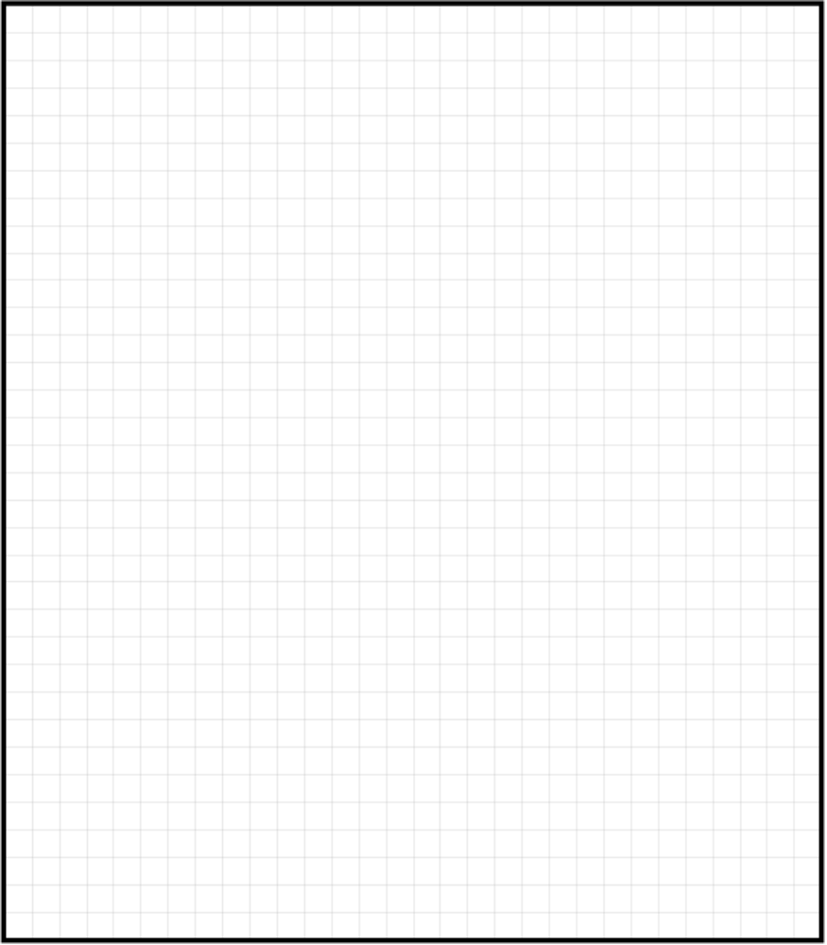

Please write your measurements as accurate as possible
Please draw your desired kitchen layout (Wall View) below:

Wall Elevate View 1 (if any)

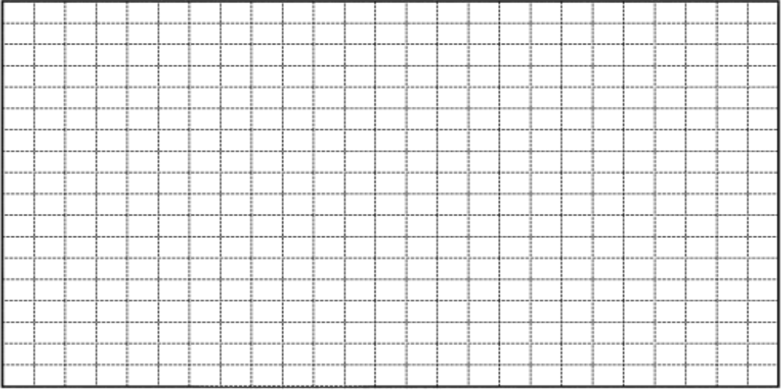

Wall Elevate View 2 (if any)

Floor Plan and Measurement Guidelines

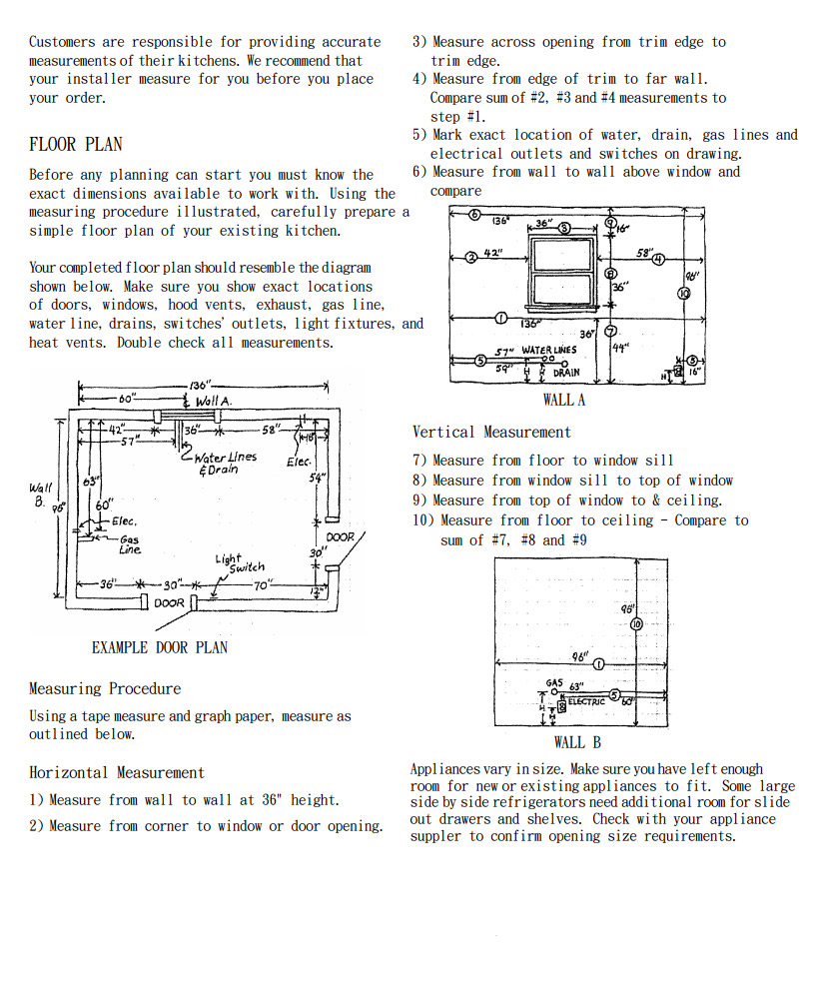

Sample Floor Plan

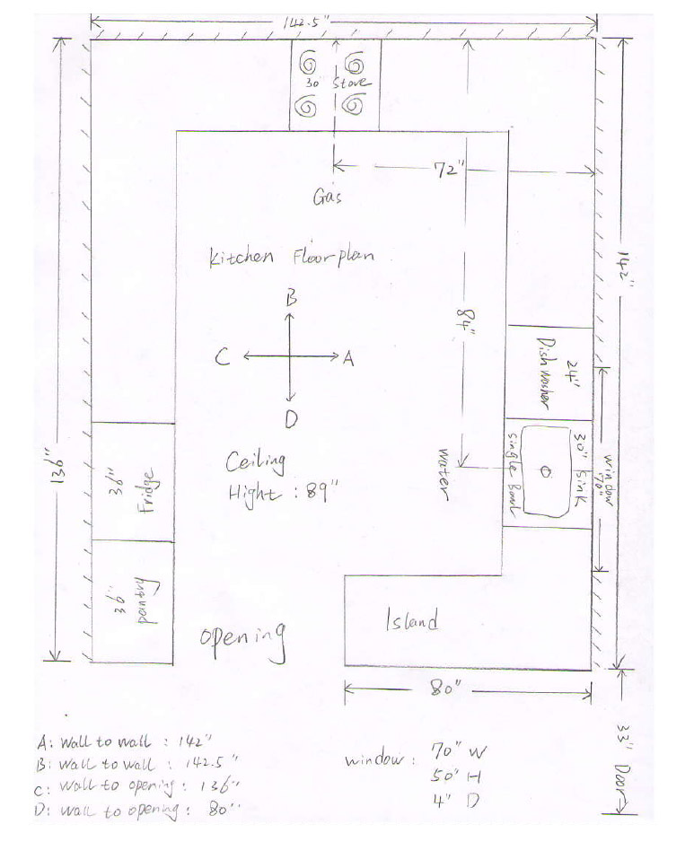

Please provide a floor plan as above sample and we will be able to design the rest for you

Sample Elevate Plan



